Neural Network
Neural networks are machine learning models that mimic the complex functions of the human brain. These models consist of interconnected nodes or neurons that process data, learn patterns and enable tasks such as pattern recognition and decision-making.
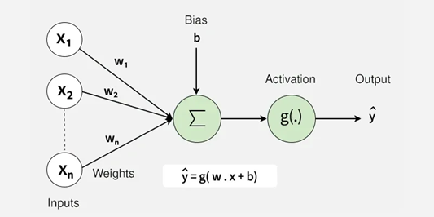
Neural networks are capable of learning and identifying patterns directly from data without pre-defined rules. These networks are built from several key components:
- Neurons: The basic units that receive inputs, each neuron is governed by a threshold and an activation function.
- Connections: Links between neurons that carry information, regulated by weights and biases.
- Weights and Biases: These parameters determine the strength and influence of connections.
- Propagation Functions: Mechanisms that help process and transfer data across layers of neurons.
- Learning Rule: The method that adjusts weights and biases over time to improve accuracy.
Layers in Neural Network Architecture
- Input Layer: This is where the network receives its input data. Each input neuron in the layer corresponds to a feature in the input data.
- Hidden Layers: These layers perform most of the computational heavy lifting. A neural network can have one or multiple hidden layers. Each layer consists of units (neurons) that transform the inputs into something that the output layer can use.
- Output Layer: The final layer produces the output of the model. The format of these outputs varies depending on the specific task like classification, regression.
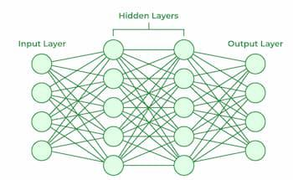
Parameters = things the network learns automatically (weights, biases).
Hyperparameters = things we set before training that control how the network learns.
Hidden Layer Size: The "hidden layer size" in a neural network, referring to the number of nodes or neurons in a hidden layer, is determined experimentally and depends on the complexity of the problem, data, and desired performance. There's no single rule, but you can start with a few nodes (e.g., between input and output layer sizes), gradually increase the size, and monitor for issues like underfitting (too few neurons) or overfitting (too many neurons), using cross-validation to find the optimal size.
Regularization : It is a technique used in machine learning and neural networks to prevent overfitting.
- Overfitting means the model learns the training data too well (including noise and unnecessary details), so it performs badly on new, unseen data.
- Regularization makes the model simpler and more general, so it works better on new data.
- Loss=Error+Penalty (on weights)
Weights define how much important the input is. Every input feature is multiplied by weight when it reaches to the neuron. Then neuron sums up all to decide which is the correct output.
penalty = extra cost added to the loss function whenever weights become too large
Without penalty → model may assign very large weights → it will memorize training data (overfitting).
With penalty → model prefers smaller, simpler weights → better generalization.
Think of penalty like a fine or tax:
- If you drive too fast (weights too big), you pay a fine (penalty).
- Because of the fine, you naturally drive slower (weights stay smaller).
Regularization types:
There are two common types:
- Lasso (L1 Regularization):
  - It adds a penalty based on the absolute value of the model’s coefficients (weights).
  - This often makes some coefficients become exactly zero → meaning the model completely ignores some features.
  - It’s like saying: “Out of 10 features, only 3-4 are really important, so let’s keep those and throw away the rest.”
  - Useful when you also want feature selection.
- Ridge (L2 Regularization):
  - It adds a penalty based on the squared values of the coefficients.
  - It makes all coefficients smaller but doesn’t usually make them zero.
  - It’s like saying: “All features are useful to some extent, but let’s not give too much importance to any one of them.”
  - Works well when features are highly correlated.
In short:
- Lasso (L1): Selects only the most important features.
- Ridge (L2): Keeps all features but balances their importance.
Lasso Regularization (L1)
- In Lasso regression, the cost function is:
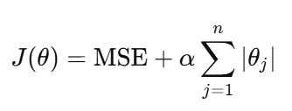
- Here, α is the regularization strength parameter.
- Role of alpha:
  - If α is large → stronger penalty → more coefficients are pushed to zero (feature selection happens).
  - If α is small → weaker penalty → model behaves more like normal regression.
🔹 Ridge Regularization (L2)
- In Ridge regression, the cost function is:
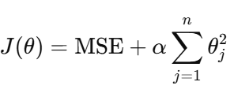
- Here too, α controls the strength of the penalty.
  - Larger α→ coefficients shrink more.
  - Smaller α → less shrinkage.
Activation Function:
While building a neural network, one key decision is selecting the Activation Function for both the hidden layer and the output layer. It is a mathematical function applied to the output of a neuron. It introduces non-linearity into the model, allowing the network to learn and represent complex patterns in the data. Without this non-linearity feature a neural network would behave like a linear regression model no matter how many layers it has.
Activation function decides whether a neuron should be activated by calculating the weighted sum of inputs and adding a bias term. This helps the model make complex decisions and predictions by introducing non-linearities to the output of each neuron.
Non-linearity means that the relationship between input and output is not a straight line. In simple terms the output does not change proportionally with the input. A common choice is the ReLU function defined as σ(x)=max(0,x).
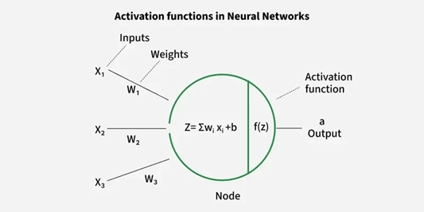
Imagine you want to classify apples and bananas based on their shape and color.
- If we use a linear function it can only separate them using a straight line.
- But real-world data is often more complex like overlapping colors, different lighting, etc.
- By adding a non-linear activation function like ReLU, Sigmoid or Tanh the network can create curved decision boundaries to separate them correctly.
Multilayer Perceptron
Perceptron: one neuron, simple linear classifier.
Multilayer Perceptron: multiple layers of neurons, can solve complex, non-linear problems.
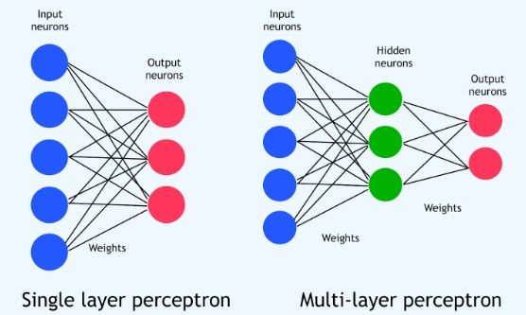
Multi-Layer Perceptrons (MLPs) are a type of neural network commonly used for classification tasks where the relationship between features and target labels is non-linear. They are particularly effective when traditional linear models are insufficient to capture complex patterns in data.
Multi-Layer Perceptron (MLP) has multiple layers of connected nodes also known as neurons and is frequently used for different machine learning tasks including classification and regression. Its architecture is given below:
1. Input Layer: This layer is composed of neurons that receive the features of the dataset. Each neuron in the input layer represents a specific feature of the data. The number of neurons in the input layer equals the number of features in the dataset.
2. Hidden Layer: One or more hidden layers may exist between the input and output layers. The number of hidden layers and neurons in each hidden layer is determined by hyperparameters
3. Output Layer: The final predictions or outputs are generated by the output layer using the data processed in the hidden levels.
- For binary classification: the output layer typically contains a single neuron with a sigmoid activation function. The sigmoid function outputs a probability between 0 and 1.
- For multi-class classification: the output layer has as many neurons as there are classes in the task with each neuron producing a probability for a particular class. The probabilities are computed using the softmax activation function which ensures the sum of all output neuron probabilities equals 1.
from sklearn.neural_network import MLPClassifier
mlp = MLPClassifier(hidden_layer_sizes=(64, 32), max_iter=1000, random_state=42)
MLPClassifier → a neural network for classification.
hidden_layer_sizes=(64, 32) → two hidden layers, 64 and 32 neurons.
max_iter=1000 → train the network for up to 1000 iterations.
random_state=42 → same results every time you run it.
Story:
Recognizing a pen → Neural network learning features
- Seeing many pens trains your brain (or the network) to recognize the general concept.
- In neural networks, this is like training on many examples so the weights capture the important features.
Importance of some pens → Weights
- You are better at drawing pens you’ve seen often → high weights.
- Less familiar pens get less attention → low weights.
- Overfitting occurs if the network gives too much weight to specific examples and fails on new pens.
- Regularization (L1/L2 penalty) reduces the weights to prevent overfitting.
Effort to decide if an object is a pen → Activation function
- Activation functions decide whether a neuron “fires” (i.e., whether a feature is significant enough to contribute).
- You recall features only when they matter enough → like a neuron activating for strong signals.
Things you notice but aren’t important → Bias
- Even if a feature isn’t strongly connected to a pen, your brain might still notice it → bias term.
- Bias allows neurons to shift their activation, so they can detect features even if the input alone is zero or weak.
Penalty → Regularization
- Penalty (L1/L2) keeps weights small so that the network doesn’t overfit and generalizes well, just like focusing on the essential features of a pen rather than memorizing every detail of each pen you’ve ever seen.

